**实验二 简单交互界面设计**

1. **实验目的**

学会PC端网站页面设计

1. **实验内容**

自己手动制作一个以HTML，CSS，JavaScript为构件体系的户外旅行网站

**三、实验环境**

Dreamweaver

**四、实验步骤**

1.先制作整个网络的框架和排版，本网页设计一共手动制作三个页面。旅游网站为Travel.html里面包括了整个网站的结构，博客，订购项目，订购活动等。点击订购支付时，会跳转到支付界面Pay.html，点击查看博客全文时，会跳转到博客界面Blog.html。

2.再运用不同的标签来完善各部分的细节。

3.运用CSS和JavaScript来增加一些文字特效。

4.将网页与网页之间界面的跳转结合起来。

**五、实验结果及代码**

**Travel.html：**

<!DOCTYPE html>

<html>

<head>

<title>Home</title>

<!--文档描述 -->

<meta charset="UTF-8">

<meta name="description" content="Activity-Order-System">

<meta name="keywords" content="zss">

<meta name="author" content="Zhaoshishu">

<script>

addEventListener("load", function () {

setTimeout(hideURLbar, 0);

}, false);

function hideURLbar() {

window.scrollTo(0, 1);//坐标

}

</script>

<!--booststrap-->

<link href="css/bootstrap.min.css" rel="stylesheet" type="text/css" media="all">

<!--//booststrap end-->

<!-- font-awesome icons -->

<link href="css/font-awesome.min.css" rel="stylesheet">

<!-- //font-awesome icons -->

<!--stylesheets-->

<link href="css/style.css" rel="stylesheet" type="text/css" media="all">

<!--//stylesheets-->

<link href="http://fonts.googleapis.com/css?family=Lobster" rel="stylesheet">

<link href="http://fonts.googleapis.com/css?family=Raleway:400,500,600,700" rel="stylesheet">

<link href="http://fonts.googleapis.com/css?family=Roboto:400,500,700" rel="stylesheet">

</head>

<body>

<!-- //banner -->

<div class="banner-left-side" id="home">

<!-- header -->

<div class="headder-top">

<!-- nav -->

<nav>

<div id="logo">

<h1>

<a href="index.html">Adventure</a>

</h1>

</div>

<label for="drop" class="toggle">Menu</label>

<input type="checkbox" id="drop">

<ul class="menu mt-2">

<li class="active">

<a href="index.html">主页</a>

</li>

<li>

<a href="#about">关于我们</a>

</li>

<li>

<a href="#service">服务</a>

</li>

<li>

<!-- First Tier Drop Down -->

<!--<label for="drop-2" class="toggle toogle-2">Dropdown <span class="fa fa-angle-down" aria-hidden="true"></span>

</label>

<a href="#">Dropdown <span class="fa fa-angle-down" aria-hidden="true"></span></a>

<input type="checkbox" id="drop-2">

<ul>

<li><a href="gallery.html" class="drop-text">Gallery</a></li>

<li><a href="menu.html" class="drop-text">Menu</a></li>

<li><a href="recipe.html" class="drop-text">Recipes</a></li>

</ul>

</li>-->

<li>

<a href="#blog">博客</a>

</li>

<li>

<a href="#contact">联系我们</a>

</li>

</li>

</ul>

</nav>

<!-- //nav -->

</div>

<!-- //header -->

<!-- banner -->

<div class="main-banner">

<div class="container">

<div class="banner-position-main">

<div class="banner-right-txt">

<h5 class="mb-sm-3 mb-2">冒险 & 欢乐</h5>

<h4><marquee>从这里开始</h4></marquee>

</div>

</div>

</div>

</div>

</div>

<!-- //banner -->

<!-- about -->

<section class="about py-lg-4 py-md-4 py-sm-3 py-3" id="about">

<div class="container py-lg-5 py-md-4 py-sm-4 py-3">

<div class="row">

<div class="col-lg-3 col-sm-6 abut-img-two my-3">

<img src="images/ab1.jpg" alt="" class="img-fluid">

</div>

<div class="col-lg-3 col-sm-6 abut-img-two my-3">

<img src="images/ab2.jpg" alt="" class="img-fluid">

</div>

<div class="col-lg-3 col-sm-6 left-abut-txt my-3">

<h3 class="title mb-2">有我们在，</h3>

<div class="title-w3ls-text mb-lg-4 mb-md-4 mb-sm-3 mb-3">

<h6>

哪里都是您的户外。

</h6>

</div>

<div class="about-right-grid">

<p>你是否想过漫步于碧绿幽深的碧潭青山？你是否想象过立足于大山之巅与大自然试比高？你是否想象过像雄鹰一样在空中飞翔？ </p>

</div>

</div>

<div class="col-lg-3 col-sm-6 abut-img-two my-3">

<img src="images/ab3.jpg" alt="" class="img-fluid">

</div>

</div>

</div>

</section>

<!--//about -->

<!-- tour-info -->

<section class="store-info py-lg-4 py-md-4 py-sm-3 py-3">

<div class="container py-lg-5 py-md-4 py-sm-4 py-3">

<h3 class="title text-center mb-2 clr">让我们开始选择您冒险的伴侣</h3>

<div class="title-w3ls-text text-center mb-lg-5 mb-md-4 mb-sm-4 mb-3">

<h6>多种类型，供您所选</h6>

</div>

<div class="row text-center">

<div class="col-lg-2 col-md-4 col-sm-6 my-3 booking-choose">

<div class="adventure-tour-wthree">

<span class="fa fa-ship" aria-hidden="true"></span>

<h4 class="mt-lg-3 mt-2">大海</h4>

</div>

</div>

<div class="col-lg-2 col-md-4 col-sm-6 my-3 booking-choose">

<div class="adventure-tour-wthree">

<span class="fa fa-shopping-bag" aria-hidden="true"></span>

<h4 class="mt-lg-3 mt-2">沙漠</h4>

</div>

</div>

<div class="col-lg-2 col-md-4 col-sm-6 my-3 booking-choose">

<div class="adventure-tour-wthree">

<span class="fa fa-paw" aria-hidden="true"></span>

<h4 class="mt-lg-3 mt-2">野生动物</h4>

</div>

</div>

<div class="col-lg-2 col-md-4 col-sm-6 my-3 booking-choose">

<div class="adventure-tour-wthree">

<span class="fa fa-fire" aria-hidden="true"></span>

<h4 class="mt-lg-3 mt-2">极地</h4>

</div>

</div>

<div class="col-lg-2 col-md-4 col-sm-6 my-3 booking-choose">

<div class="adventure-tour-wthree">

<span class="fa fa-area-chart" aria-hidden="true"></span>

<h4 class="mt-lg-3 mt-2">山峰</h4>

</div>

</div>

<div class="col-lg-2 col-md-4 col-sm-6 my-3 booking-choose">

<div class="adventure-tour-wthree">

<span class="fa fa-paper-plane-o" aria-hidden="true"></span>

<h4 class="mt-lg-3 mt-2">天空</h4>

</div>

</div>

</div>

</div>

</section>

<!--//tour-info -->

<!-- service -->

<section class="service py-lg-4 py-md-4 py-sm-3 py-3" id="service">

<div class="container py-lg-5 py-md-4 py-sm-4 py-3">

<h3 class="title text-center mb-2">服务</h3>

<div class="title-w3ls-text text-center mb-lg-5 mb-md-4 mb-sm-4 mb-3">

<h6>我们为您精心定制了优惠</h6>

</div>

<div class="row">

<div class="col-lg-4 col-md-6 col-sm-6 ser-icon my-3">

<div class="grid-wthree-service">

<span class="fa fa-money" aria-hidden="true"></span>

<div class="ser-text-wthree mt-3">

<h4>

无门槛VIP！

</h4>

<p class="mt-2">只要您选择了我们，每个人都可以收到我们为您准备的专属VIP套餐，我们定将倾尽所有为您保驾护航</p>

</div>

</div>

</div>

<div class="col-lg-4 col-md-6 col-sm-6 ser-icon my-3">

<div class="grid-wthree-service">

<span class="fa fa-arrow-up" aria-hidden="true"></span>

<div class="ser-text-wthree mt-3">

<h4>

免费保险，出行无忧！

</h4>

<p class="mt-2">我们将为您提供全程免费保险，您的安全是我最大的职责。</p>

</div>

</div>

</div>

<div class="col-lg-4 col-md-6 col-sm-6 ser-icon my-3">

<div class="grid-wthree-service">

<span class="fa fa-laptop" aria-hidden="true"></span>

<div class="ser-text-wthree mt-3">

<h4>

新用户立减，上不封顶！

</h4>

<p class="mt-2">新用户下单，立减20%。</p>

</div>

</div>

</div>

<div class="col-lg-4 col-md-6 col-sm-6 ser-icon my-3">

<div class="grid-wthree-service">

<span class="fa fa-users" aria-hidden="true"></span>

<div class="ser-text-wthree mt-3">

<h4>

团购与户外更配哦！

</h4>

<p class="mt-2">团购(满10人)，每人票价减10%，团购(满20)人，每人票价减20%，团购(满30人)，每人票价立减30！</p>

</div>

</div>

</div>

<div class="col-lg-4 col-md-6 col-sm-6 ser-icon my-3">

<div class="grid-wthree-service">

<span class="fa fa-globe" aria-hidden="true"></span>

<div class="ser-text-wthree mt-3">

<h4>

专属导游！

</h4>

<p class="mt-2">您的每一次远足，我们都会为您准备贴心的导游，游玩路线精心规划，让您时刻感受到家的感觉</p>

</div>

</div>

</div>

<div class="col-lg-4 col-md-6 col-sm-6 ser-icon my-3">

<div class="grid-wthree-service">

<span class="fa fa-map" aria-hidden="true"></span>

<div class="ser-text-wthree mt-3">

<h4>

转发分享，红包秒到账！

</h4>

<p class="mt-2">转发分享该网页到朋友圈，集赞满70个，即可获得满1000减300，满2000减600的优惠券。上不封顶。</p>

</div>

</div>

</div>

</div>

</div>

</section>

<!--<!--<!--//service -->

<!-- some-text -->

<div class="title-w3ls-text text-center mb-lg-5 mb-md-4 mb-sm-4 mb-3">

<h6>个人博客--分享你的快乐</h6>

<section class="blog" id="blog">

<div class="container-fluid">

<div class="row">

<div class="col-lg-6 col-md-6 blog-two-two p-0">

<div class="blog-wthree-list">

<div class="blog-date-time mb-2">

<ul>

<li>

<a href="#contact">用户: 我是大自然的孩子/2019.7.20/</a>

</li>

<li>

<a href="#contact">评论个数:11,900</a>

</li>

</ul>

</div>

<h4 class="mb-3">

<a href="#contact">记第一次征服珠穆朗玛峰</a>

</h4>

<p>

珠穆朗玛峰，号称世界第三极，离天空最近的地方。

亿万年的沧海桑田，造就了这个神话。也许他脚下的一块土地，

曾经是我们祖先缘木取火的所在，但此时这里很安静，没有俗世的繁华喧闹；

也许厚厚的冰川，有一颗是藏家卓玛思念情人滴下的泪珠......

</p>

<div class="view-buttn mt-md-4 mt-sm-4 mt-3">

<a href="#contact" class="btn">阅读更多</a>

</div>

</div>

</div>

<div class="col-lg-6 col-md-6 p-0 blog-img-one">

<div class="blog-wthree-list">

<div class="blog-date-time mb-2">

<ul>

<li>

<a href="#contact">用户: 97983我爱你/2019 7.30/</a>

</li>

<li>

<a href="#contact">评论个数:3,283</a>

</li>

</ul>

</div>

<h4 class="mb-3">

<a href="#contact">你好，香格里拉。你好，我的爱人</a>

</h4>

<p>

这里是香格里拉，我在这里，静静守候一个又一个的春夏秋冬。

我们在这片滇西北大地上，不寻求梦中的香格里拉，只为找寻一份属于自己的爱情。

幸运的是，我们终将在这片土地上遇见你，遇见爱情，遇见所有的喜怒哀乐和春暖花开......

</p>

<div class="view-buttn mt-md-4 mt-sm-4 mt-3">

<a href="#contact" class="btn">阅读更多</a>

</div>

</div>

</div>

<div class="col-lg-6 col-md-6 p-0 blog-img-two">

<div class="blog-wthree-list">

<div class="blog-date-time mb-2">

<ul>

<li>

<a href="#contact">用户: 浪啊浪888/2019.8.5/</a>

</li>

<li>

<a href="#contact">评论个数:10,389</a>

</li>

</ul>

</div>

<h4 class="mb-3">

<a href="#contact">普吉岛--大自然给予的冲浪天堂</a>

</h4>

<p>

跟朋友一直有出国旅游的计划，由于时间比较紧迫，

所以也没有选择太远的目的地，于是泰国普吉岛无疑成了最好的选择。

而且泰国是一个非常迷人的国家，十分具有异域特色，

这也是吸引我前往的一个重要的原因......

</p>

<div class="view-buttn mt-md-4 mt-sm-4 mt-3">

<a href="#contact" class="btn">阅读更多</a>

</div>

</div>

</div>

<div class="col-lg-6 col-md-6 blog-two-two p-0">

<div class="blog-wthree-list">

<div class="blog-date-time mb-2">

<ul>

<li>

<a href="#contact">用户: 来不及说我爱你/2019.8.6/</a>

</li>

<li>

<a href="#contact">评论个数:1,283</a>

</li>

</ul>

</div>

<h4 class="mb-3">

<a href="#contact">撒哈拉，最好看的沙漠</a>

</h4>

<p>

今年我有个心愿，就是要开启一场沙漠之旅，没想到沙漠之约这么快就来到了，竟然还是撒哈拉沙漠，惊喜！

在埃及，我的导游小龙介绍说，撒哈拉沙漠是世界上最好看的沙漠，比其他的沙漠都好看。究竟好看到什么程度呢？我非常的期待。

</p>

<div class="view-buttn mt-md-4 mt-sm-4 mt-3">

<a href="#contact" class="btn">阅读更多</a>

</div>

</div>

</div>

</div>

</div>

</section>

<!--//blog -->

<!-- booking -->

<section class="py-lg-4 py-md-3 py-sm-3 py-3">

<div class="container py-lg-5 py-md-4 py-sm-4 py-3">

<h3 class="title text-center mb-2">订购</h3>

<div class="title-w3ls-text text-center mb-lg-5 mb-md-4 mb-sm-4 mb-3">

<h6>您的选择</h6>

</div>

<div class="row">

<div class="col-lg-3 col-md-6 col-sm-6 my-3 adventure-trip-grids">

<div class="discount-adventure-one">

<div class="rating-start ">

<ul>

<li>

<a href="#">

<span class="fa fa-star" aria-hidden="true"></span>

</a>

</li>

<li>

<a href="#">

<span class="fa fa-star" aria-hidden="true"></span>

</a>

</li>

<li>

<a href="#">

<span class="fa fa-star" aria-hidden="true"></span>

</a>

</li>

<li>

<a href="#">

<span class="fa fa-star-half-o" aria-hidden="true"></span>

</a>

</li>

<li>

<a href="#">

<span class="fa fa-star-o" aria-hidden="true"></span>

</a>

</li>

</ul>

</div>

</div>

<div class="discount-txt">

<h6>撒哈拉极地徒步</h6>

<p class="pt-lg-3 pt-2">对懂得欣赏它的人，它是无价的，让我们一起来感受撒哈拉的魅力！</p>

<div class="row mt-3">

<div class="col-lg-6 col-md-6 col-sm-6 button-arrow ">

<a href="file:///D:/github/Code-Practice/Web/%E6%88%B7%E5%A4%96%E6%97%85%E8%A1%8C%E7%BD%91%E7%AB%99/Pay.html" class="btn">点击订购</a>

</div>

<div class="col-lg-6 col-md-6 col-sm-6 price-rate">

<h6>RMB: 2,250</h6>

</div>

</div>

</div>

</div>

<div class="col-lg-3 col-md-6 col-sm-6 my-3 adventure-trip-grids">

<div class="discount-adventure-two">

<div class="rating-start ">

<ul>

<li>

<a href="#">

<span class="fa fa-star" aria-hidden="true"></span>

</a>

</li>

<li>

<a href="#">

<span class="fa fa-star" aria-hidden="true"></span>

</a>

</li>

<li>

<a href="#">

<span class="fa fa-star" aria-hidden="true"></span>

</a>

</li>

<li>

<a href="#">

<span class="fa fa-star-half-o" aria-hidden="true"></span>

</a>

</li>

<li>

<a href="#">

<span class="fa fa-star-o" aria-hidden="true"></span>

</a>

</li>

</ul>

</div>

</div>

<div class="discount-txt">

<h6>珠穆朗玛峰飞翔</h6>

<p class="pt-lg-3 pt-2">给您一个翅膀，您就可以在珠穆朗玛峰上面翱翔</p>

<div class="row mt-3">

<div class="col-lg-6 col-md-6 col-sm-6 button-arrow ">

<a href="file:///D:/github/Code-Practice/Web/%E6%88%B7%E5%A4%96%E6%97%85%E8%A1%8C%E7%BD%91%E7%AB%99/Pay.html" class="btn">点击订购</a>

</div>

<div class="col-lg-6 col-md-6 col-sm-6 price-rate">

<h6>RMB 6,999</h6>

</div>

</div>

</div>

</div>

<div class="col-lg-3 col-md-6 col-sm-6 my-3 adventure-trip-grids">

<div class="discount-adventure-three">

<div class="rating-start ">

<ul>

<li>

<a href="#">

<span class="fa fa-star" aria-hidden="true"></span>

</a>

</li>

<li>

<a href="#">

<span class="fa fa-star" aria-hidden="true"></span>

</a>

</li>

<li>

<a href="#">

<span class="fa fa-star" aria-hidden="true"></span>

</a>

</li>

<li>

<a href="#">

<span class="fa fa-star-half-o" aria-hidden="true"></span>

</a>

</li>

<li>

<a href="#">

<span class="fa fa-star-o" aria-hidden="true"></span>

</a>

</li>

</ul>

</div>

</div>

<div class="discount-txt">

<h6>亚马逊探险</h6>

<p class="pt-lg-3 pt-2">在这里，您可以与很多罕见的野生动物交朋友，远离喧嚣，融入大自然。</p>

<div class="row mt-3">

<div class="col-lg-6 col-md-6 col-sm-6 button-arrow ">

<a href="file:///D:/github/Code-Practice/Web/%E6%88%B7%E5%A4%96%E6%97%85%E8%A1%8C%E7%BD%91%E7%AB%99/Pay.html" class="btn">点击订购</a>

</div>

<div class="col-lg-6 col-md-6 col-sm-6 price-rate ">

<h6>RMB 9,999</h6>

</div>

</div>

</div>

</div>

<div class="col-lg-3 col-md-6 col-sm-6 my-3 adventure-trip-grids">

<div class="discount-adventure-four">

<div class="rating-start ">

<ul>

<li>

<a href="#">

<span class="fa fa-star" aria-hidden="true"></span>

</a>

</li>

<li>

<a href="#">

<span class="fa fa-star" aria-hidden="true"></span>

</a>

</li>

<li>

<a href="#">

<span class="fa fa-star" aria-hidden="true"></span>

</a>

</li>

<li>

<a href="#">

<span class="fa fa-star-half-o" aria-hidden="true"></span>

</a>

</li>

<li>

<a href="#">

<span class="fa fa-star-o" aria-hidden="true"></span>

</a>

</li>

</ul>

</div>

</div>

<div class="discount-txt">

<h6>普吉岛冲浪</h6>

<p class="pt-lg-3 pt-2">环岛游、急速摩托艇、深海潜水等海上项目，既刺激又畅快。</p>

<div class="row mt-3">

<div class="button-arrow col-lg-6 col-md-6 col-sm-6">

<a href="file:///D:/github/Code-Practice/Web/%E6%88%B7%E5%A4%96%E6%97%85%E8%A1%8C%E7%BD%91%E7%AB%99/Pay.html" class="btn">点击订购</a>

</div>

<div class="price-rate col-lg-6 col-md-6 col-sm-6">

<h6>RMB 3,999</h6>

</div>

</div>

</div>

</div>

</div>

</div>

</section>

<!--//booking -->

<section class="subscribe py-lg-4 py-md-4 py-sm-3 py-3">

<div class="container py-lg-5 py-md-4 py-sm-4 py-3">

<h3 class="title text-center mb-2 clr">

订阅

</h3>

<div class="title-w3ls-text text-center mb-lg-5 mb-md-4 mb-sm-4 mb-3">

<h6>我们将随时向您推送我们的最新消息</h6>

</div>

<div class="newsletter-footers">

<form action="#" method="post">

<input type="email" name="邮箱号" class="form-control" placeholder="邮箱号" required="">

<button type="submit" class="btn subscribe-butn">订阅</button>

</form>

</div>

</div>

</section>

<!-- contact -->

<section class="contact py-lg-4 py-md-4 py-sm-3 py-3" id="contact">

<div class="container py-lg-5 py-md-4 py-sm-4 py-3">

<h3 class="title text-center mb-2">联系</h3>

<div class="title-w3ls-text text-center mb-lg-5 mb-md-4 mb-sm-4 mb-3">

<h6>我们随时欢迎与您的交流！</h6>

</div>

<div class="row">

<div class="col-lg-6 container-fulid">

<div class="address_mail_footer_grids">

<iframe src=""></iframe>

</div>

</div>

<div class="col-lg-6 contact-form">

<form action="#" method="post">

<div class="row">

<div class="col-lg-6 col-md-6 col-sm-6 form-group contact-forms">

<input type="text" class="form-control" placeholder="姓" required="">

</div>

<div class="col-lg-6 col-md-6 col-sm-6 form-group contact-forms">

<input type="text" class="form-control" placeholder="名" required="">

</div>

</div>

<div class="row">

<div class="col-lg-6 col-md-6 col-sm-6 form-group contact-forms">

<input type="text" class="form-control" placeholder="电话号码" required="">

</div>

<div class="col-lg-6 col-md-6 col-sm-6 form-group contact-forms">

<input type="email" class="form-control" placeholder="邮箱" required="">

</div>

</div>

<div class="form-group contact-forms">

<textarea class="form-control" placeholder="您的反馈" required=""></textarea>

</div>

<button type="submit" class="btn sent-butnn btn-lg">发送</button>

</form>

</div>

</div>

</div>

</section>

<!-- //contact -->

<section class="footer-w3layouts-bottem py-lg-4 py-md-3 py-sm-3 py-3">

<div class="container py-lg-5 py-md-5 py-sm-4 py-3">

<div class=" footer-top mt-3 text-center">

<p>

<span>Address</span> : Melbourne St,South

<br>Birbane 4101 Austraila.

</p>

<p class="pt-2">

<span> Phone</span> : +(000) 123 4565 32

</p>

<p class="pt-2">

<span>Email</span> :

<a href="mailto:info@example.com">info@example1.com</a>

</p>

</div>

<div class="social-icons text-center mt-md-4 mt-3">

<ul>

<li class="facebook">

<a href="#">

<span class="fa fa-facebook"></span>

</a>

</li>

<li class="twitter">

<a href="#">

<span class="fa fa-twitter"></span>

</a>

</li>

<li class="rss">

<a href="#">

<span class="fa fa-rss"></span>

</a>

</li>

</ul>

</div>

<!-- move icon -->

<div class="text-center mt-lg-5 mt-md-4 mt-3">

<a href="#home" class="move-top text-center mt-3">

<span class="fa fa-arrow-up" aria-hidden="true"></span>

</a>

</div>

<!--//move icon -->

</div>

</section>

</body>

</html>

**界面截图：**

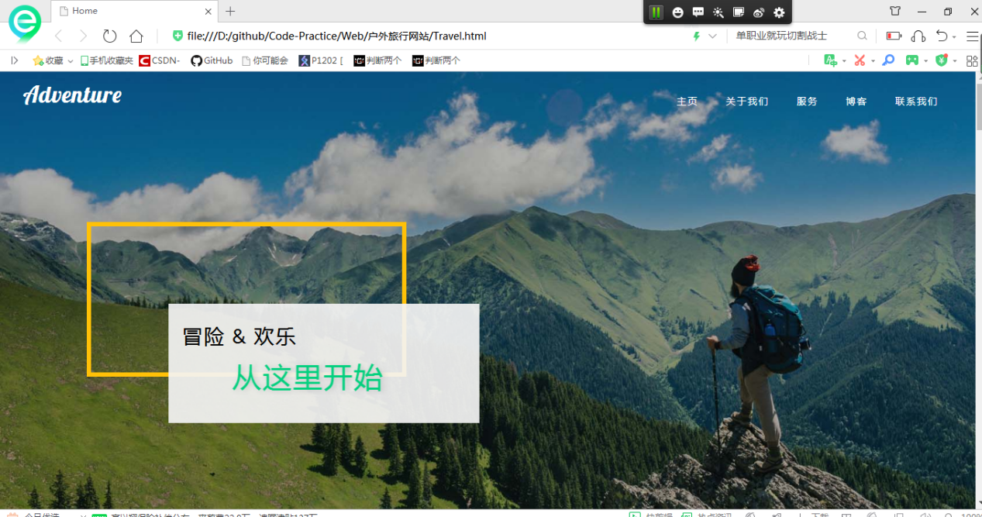

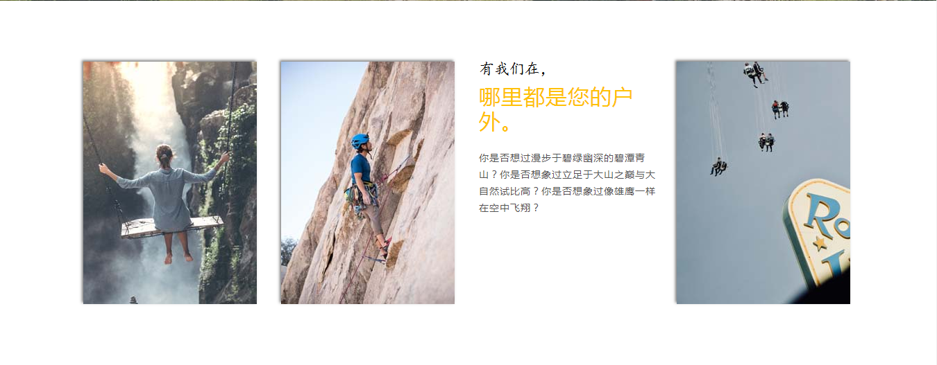

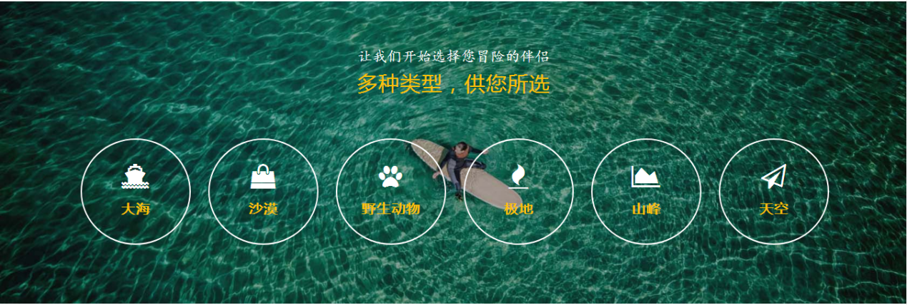

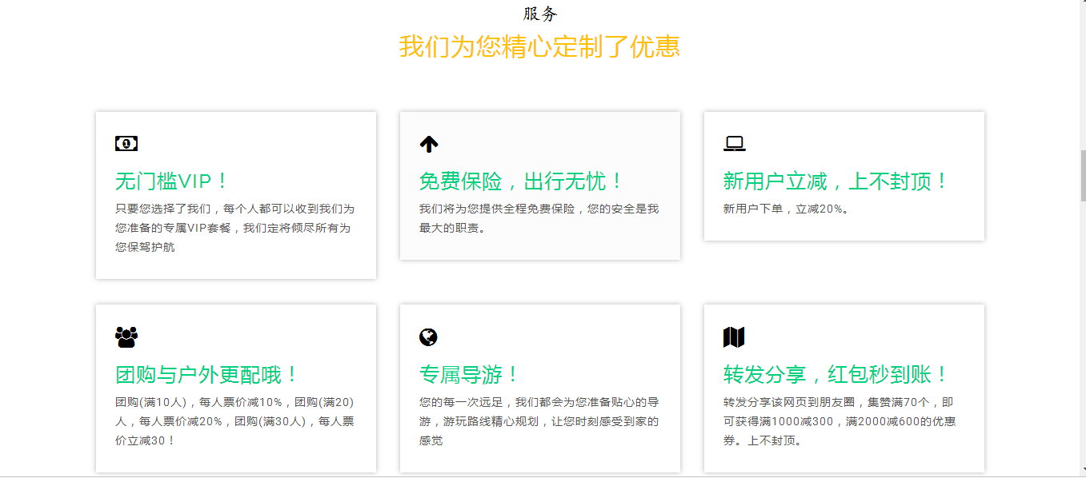

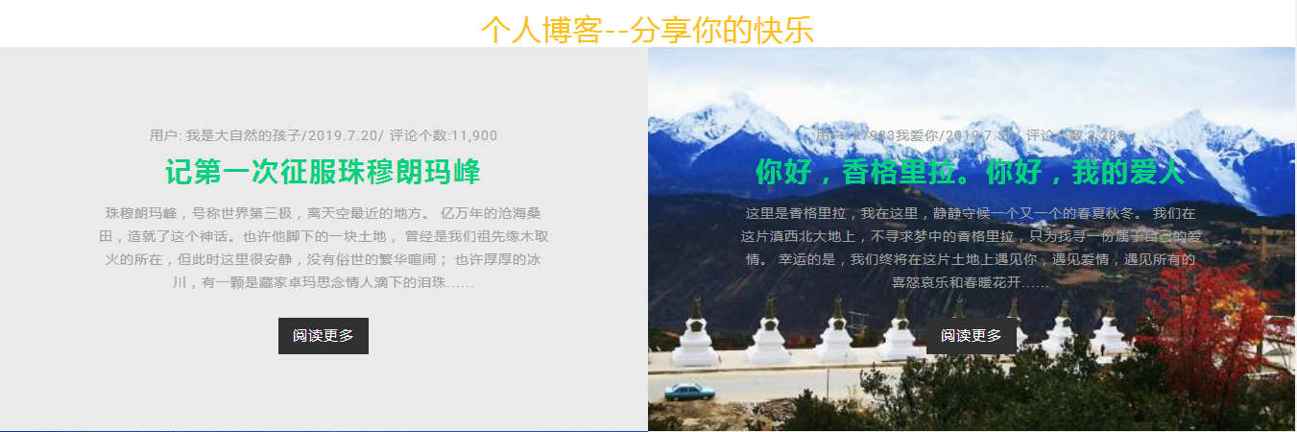

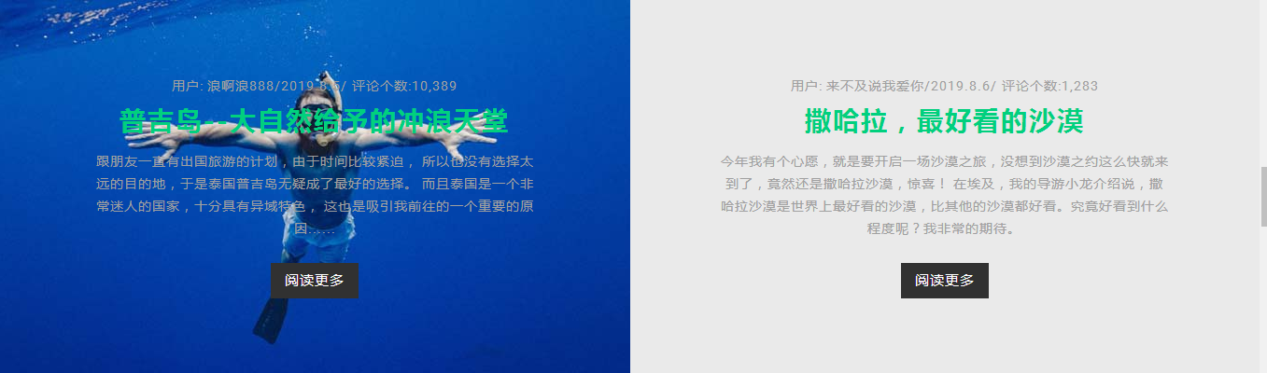

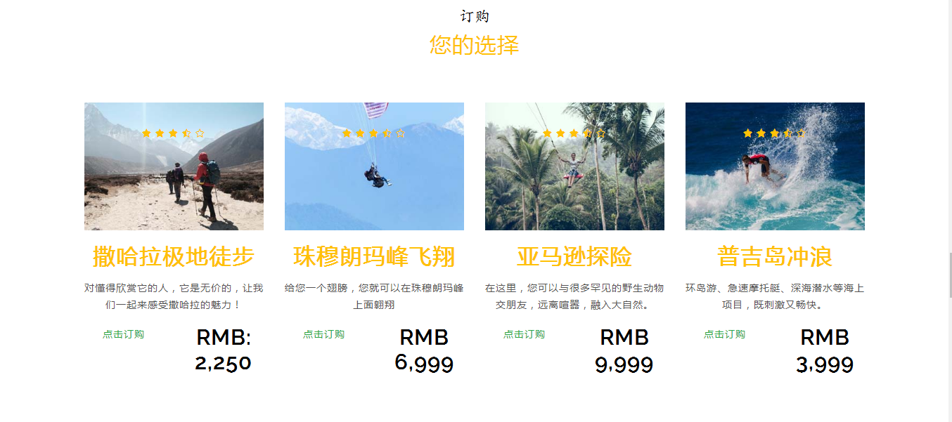

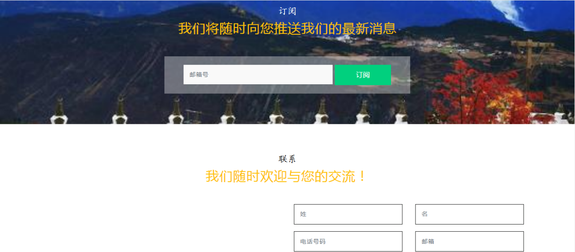

**Pay.html代码：**

<!DOCTYPE html>

<html lang="en" xmlns="http://www.w3.org/1999/xhtml">

<head>

<meta charset="utf-8" />

<title></title>

</head>

<body>

<h1>请为您的订单付款</h1>

<form action="" method="post">

<!--form规定当提交表单时向何处发送表单数据, 意思是当前的数据用post方法传递-->

<table width="60%">

<tr>

<td bgcolor="#F7FEFF" colspan="4">

<!--colspan 属性规定单元格可横跨的列数。-->

订单号：<INPUT TYPE="text" NAME="orderid">

支付金额：<INPUT TYPE="text" NAME="money" size="6">元

</td>

</tr>

<tr><td><br /></td></tr>

<tr>

<td>请您选择在线支付银行</td>

</tr>

<tr>

<td><INPUT TYPE="radio" NAME="pd_FrpId" value="CMBCHINA-NET">招商银行 </td>

<td><INPUT TYPE="radio" NAME="pd_FrpId" value="ICBC-NET">工商银行</td>

<td><INPUT TYPE="radio" NAME="pd_FrpId" value="ABC-NET">农业银行</td>

<td><INPUT TYPE="radio" NAME="pd_FrpId" value="CCB-NET">建设银行 </td>

</tr>

<tr>

<td><INPUT TYPE="radio" NAME="pd_FrpId" value="CMBC-NET">中国民生银行总行</td>

<td><INPUT TYPE="radio" NAME="pd_FrpId" value="CEB-NET">光大银行 </td>

<td><INPUT TYPE="radio" NAME="pd_FrpId" value="BOCO-NET">交通银行</td>

<td><INPUT TYPE="radio" NAME="pd_FrpId" value="SDB-NET">深圳发展银行</td>

</tr>

<tr>

<td><INPUT TYPE="radio" NAME="pd_FrpId" value="BCCB-NET">北京银行</td>

<td><INPUT TYPE="radio" NAME="pd_FrpId" value="CIB-NET">兴业银行 </td>

<td><INPUT TYPE="radio" NAME="pd_FrpId" value="SPDB-NET">上海浦东发展银行 </td>

<td><INPUT TYPE="radio" NAME="pd_FrpId" value="ECITIC-NET">中信银行</td>

</tr>

<tr><td><br /></td></tr>

<tr>

<td><INPUT TYPE="submit" value="确定支付"></td>

</tr>

</table>

</form>

</body>

</html>

**界面截图：**

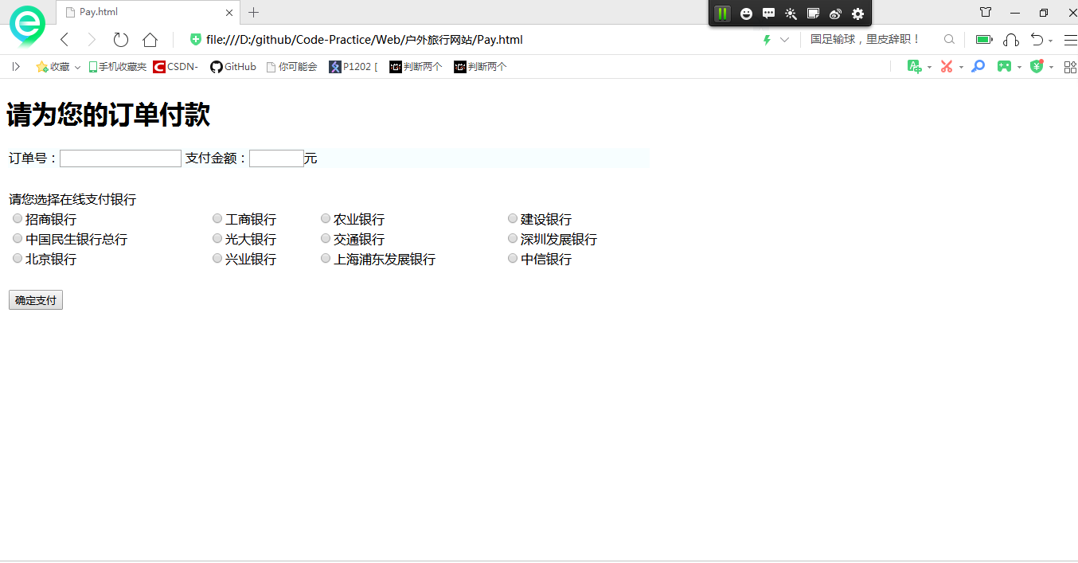

**Blog.html：**

<!DOCTYPE html>

<html lang="en" xmlns="http://www.w3.org/1999/xhtml">

<head>

<meta charset="utf-8" />

<title></title>

</head>

<body>

<div style="width: 980px; margin:0 auto">

<!--header begin-->

<div style="height:56;">

<img src="images2/logo.png" alt="" align="left" />

<p align="right">博客首页&nbsp;&nbsp;|&nbsp;&nbsp;登录&nbsp;&nbsp;|&nbsp;&nbsp;注册</p>

</div>

<hr color="#CCC" />

<!--header end-->

<!--说旅游begain-->

<div style="height:470px">

<img src="images2/banner1.jpg" alt="" align="left" hspace="12" vspace="12" />

<div>

<p align="content">

<strong>

<font face="微软雅黑" size="6" color="oranfe">说</font>

<font face="微软雅黑" size="7" color="oranfe">旅</font>

<font face="微软雅黑" size="6" color="oranfe">游</font>

</strong>

</p>

<p>

&nbsp;&nbsp;&nbsp;&nbsp;珠穆朗玛峰，号称世界第三极，离天空最近的地方。

</p>

<p>

&nbsp;&nbsp;&nbsp;&nbsp;最佳旅游时间：<ins>

<em>

<strong>

<font color="#009933">6月-9月</font>

</strong>

</em>

</ins>,寒风气候。<ins>

<em>

<strong>

<font color="#009933">12月至次年4月</font>

</strong>

</em>

</ins>可避免高峰。

</p>

<p>

&nbsp;&nbsp;&nbsp;&nbsp; 亿万年的沧海桑田，造就了这个神话。<ins>

<strong>

<font color="#F90">......[详细]</font>

</strong>

</ins>

</p>

</div>

</div>

<!--说旅游end-->

<!--有你真好begain-->

<div>

<h2>记第一次征服珠穆朗玛峰</h2>

<p>

<em>

<font color="#666666">

2015.04.24&nbsp;&nbsp;&nbsp;&nbsp;来源：一日驴友群-老牛

</font>

</em>

</p>

<hr color="#CCC" />

<p>

&nbsp;&nbsp;&nbsp;&nbsp;&nbsp;&nbsp;也许他脚下的一块土地，

曾经是我们祖先缘木取火的所在，但此时这里很安静，没有俗世的繁华喧闹；

也许厚厚的冰川，有一颗是藏家卓玛思念情人滴下的泪珠......。

</p>

<img src="images2/banner2.jpg" alt="" vaspce="20" />

</div>

<!--有你真好end-->

<!--评论begain-->

<div>

<img src="images2/icon.gif" alt="" />

<hr color="#CCC" />

<div>

<img src="images2/person1.jpg" alt="" align="left" hspace="10" />

<div>

<p>

<font color="#F60">HXZ9_IT</font>

&nbsp;&nbsp;&nbsp;&nbsp;

<font size="2" color="#999">2015-04-02 15:38:37</font>

</p>

<p>

<font size="2">第一次用途牛，惊喜ing!</font>

<br />

<font color="#F60" size="2">来自：一日驴友网www.sdfes.com</font>

</p>

</div>

<hr color="#CCC" size="1" />

</div>

<div>

<img src="images2/person2.jpg" alt="" align="left" hspace="10" />

<div>

<p>

<font color="#F60">外星人</font>

&nbsp;&nbsp;&nbsp;&nbsp;

<font size="2" color="#999">2015-03-02 15:25:26</font>

</p>

<p>

<font size="2">不错，很赞，好吃，下次再来！</font>

<br />

<font color="#F60" size="2">来自：一日驴友网wwwW.sdds.com</font>

</p>

</div>

<hr color="#CCC" size="1" />

</div>

<div>

<img src="images2/person3.jpg" alt="" align="left" hspace="10" />

<div>

<p>

<font color="#F60">so_cool</font>

&nbsp;&nbsp;&nbsp;&nbsp;

<font size="2" color="#999">2016-05-26 15:45:25</font>

</p>

<p>

<font size="2">很好，都可以，没问题！</font>

<br />

<font color="#F60" size="2">来自：一日驴友网wwww.sdeqqqa.com</font>

</p>

</div>

<hr color="#CCC" />

</div>

</div>

<!--评论end-->

<!--footer begain-->

<div style="text-align: center;">

<p>

<font color="#1d5983" size="2">

一日网友意见留言板&nbsp;&nbsp;&nbsp;&nbsp;

<font color="#333">

电话：12354687954

</font>

&nbsp;&nbsp;&nbsp;&nbsp;欢迎批评指正！

</font>

</p>

<p>

<font color="#1d5983" size="2">

博客网站简介 | About YIRIYOU | 广告服务 | 招聘信息 | 网站律师 | YIRIYOU English | 注册 | 产品答疑

</font>

</p>

<p>

<font size="2">

Copyright@1996 - 2016 YIRIYOU.coright AII Rights Reserved

</font>

</p>

<p>

<font color="#1d5983" size="2">

分享你的旅游时光

</font>

</p>

</div>

<!--footer end-->

</div>

</body>

</html>

**界面截图：**

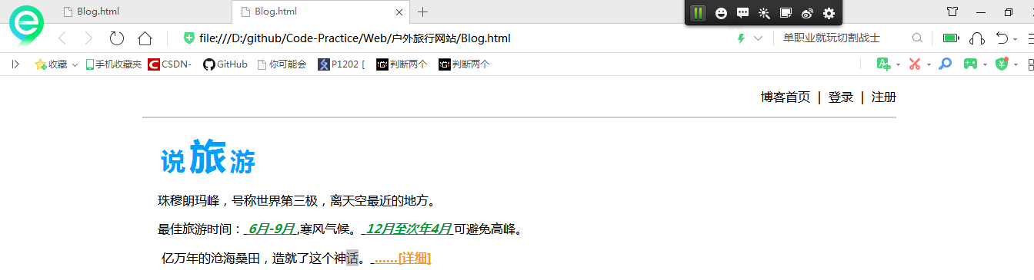

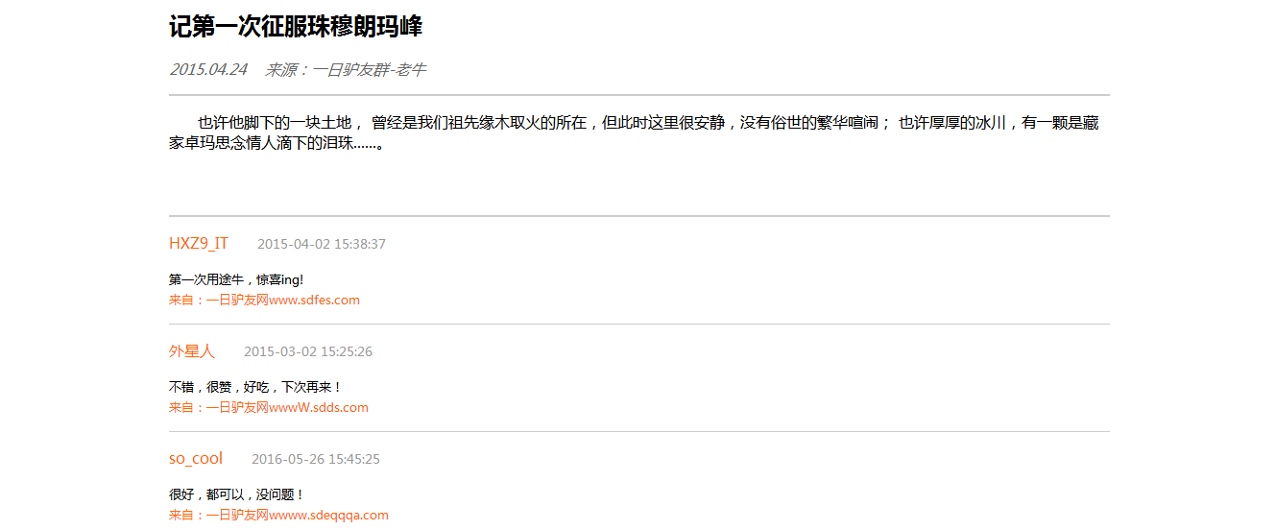

1. **实验心得**

经过这次实验，我熟练的掌握了网页制作的体系架构，熟悉了各种标签的使用以及多个网页界面之间的跳转。完成一个项目后特别有成就感，增加了我对与人机交互界面实现的兴趣。